The Staff of SW DocuFest would like to thank all our participants and SPONSORS for coming out and supporting our event!
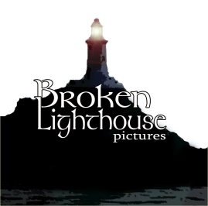

STAFF:
Kevin L. Powers, Program Director/Co-Festival Director
Howard Carter, Co-Festival Director/Hospitality
Laura Powers, Outreach Manager
Cristian Hernandez, Festival Technical Supervisor
Travis Joseph, Festival Technical Supervisor
Philip Wray, Festival Judge/Panel Moderator
My name is Kevin L Powers and I’m the Co-Festival Director and Program Director for the 2022 SW DocuFest! I am very excited to be bringing you a wide variety of non-fiction shorts and features from all different genre of documentary film-making from film-makers from all over the world. This is our second year of this spin-off event and we more than tripled our submissions and films eligible for awards.
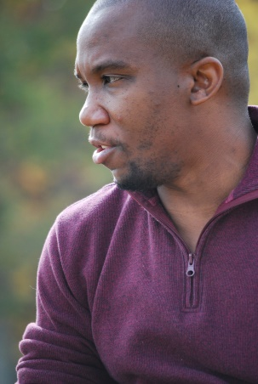
As an avid movie goer and a huge supporter of non-fiction films I am ecstatic with the results this year and with the variety of films we are able to bring to our audience. A lot of hard work and time goes into making a non-fiction film and it’s a success for every film to just get one completed much less screened at an event! Even though our event (again) will be an Online Festival Event we still hope to get people watching these amazing films even from the comfort of their own home.
For those individuals capable of coming out to our special “Best of the Festival” screening they will be in for an amazing line-up of films that all of us at Something Wicked Entertainment thought were a cut above the rest. These will again screen at Southern Performing Arts Academy but at our NEW LOCATION (!), so audience members will be in for a treat.
I’m also excited that for this year’s Special Retrospective we will highlighting documentary film-maker Nick Broomfield, whose film Fetishes (1996) was the very first documentary I saw in a theater and which changed the way I looked at what a documentary film could be beyond the Ken Burns film. The way in which he integrates himself into his films and stories is the reason why I continue to watch his films to this day. All the films that we highlight are free to view on You Tube but I also encourage viewers that if you like any of these films, then to purchase a physical or digital copy for your own collection. When you purchase these films you are supporting indie film-makers and their films.
We hope that everyone enjoys the films that we have offered up this year. Some are from student and amateur film-makers whereas others are from seasoned professionals but the one thing they all have in common is that they all have a compelling story to tell and a unique way to tell it.

Enjoy SW DocuFest 2022 and we hope to see you support this and other events that we produce in the future!

Kevin L Powers

SHORTS:
TITLE: CATO’S PROJECT ON POVERTY AND INEQUALITY IN CALIFORNIA
RUN TIME:28 MIN
SYNOPSIS:
How is it that a state like California, with pockets of vast wealth, solid economic growth, and an extensive social safety net, can nonetheless have the highest poverty rate in the nation?
For the past two and a half years, the Cato Institute’s Project on Poverty and Inequality in California has been asking this question and seeking ways in which California should reform its policies to help lift people out of poverty and to enable them to fully participate in the state’s economy.
COUNTRY OF ORIGIN: UNITED STATES
SPECIAL NOTES:
Website: https://www.cato.org/
Twitter: https://twitter.com/CatoInstitute
Instagram: https://www.instagram.com/catoinstitute/
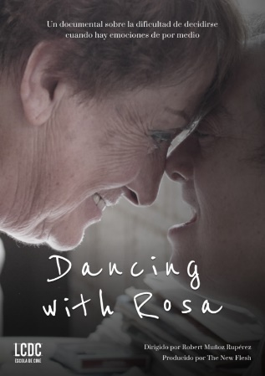
TITLE: DANCING WITH ROSA
RUN TIME: 26 MIN
SYNOPSIS:
At 84 years of age, Rosa realizes that she no longer has the strength to take care of her daughter Eva who has Down syndrome, and she struggles to decide whether or not to put her into a care home. In this intimate portrait, we follow Rosa’s pain of indecision and her unique way of coping.
COUNTRY OF ORIGIN: SPAIN

TITLE: DARKNESS BEYOND SAVINGS, THE
RUN TIME: 20 MIN
SYNOPSIS:
The documentary, shot between Empoli and Ferrara, explores the human aspect, the real repercussions of an operation in which the burden of rescuing the banks is dumped on small shareholders and holders of subordinated bonds, many of whom are unaware that their savings had been invested that way. Human affairs of families hit by a tsunami: savings of a life gone, the desperation of those who suddenly realize that they no longer have anything, the sense of shame, the stories of the "zeroed"
COUNTRY OF ORIGIN: ITALY

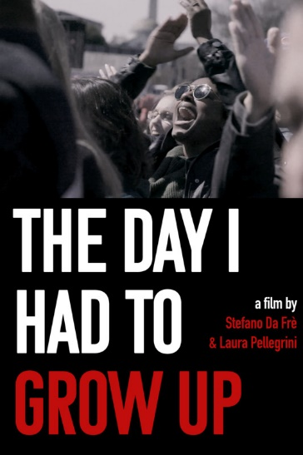
TITLE: DAY I HAD TO GROW UP, THE
RUN TIME: 20 MIN
SYNOPSIS:
Emmy Award Winning Editor Krysia Carter Giez & Directors Stefano Da Frè & Laura Pellegrini, two filmmakers who recently had their previous documentary "The Girl Who Cannot Speak" win the 'Coup de Coeur' at the Cannes Film Festival have created a new political documentary on Youth Activism.
This is a political documentary that joining forces with Activist Jeremy Ornstein to document a new voice in America's youth movement.
Stefano & Laura invite five prominent activists to New York City. Each activist has a unique, diverse, personal connection to recent national events such as the school shootings in Parkland, Florida to Black Lives Matter in America to the Green New Deal.
COUNTRY OF ORIGIN: UNITED STATES
SPECIAL NOTES:
Website: http://www.rossofilmsinternational.com/
Instagram: https://www.instagram.com/thedayfilm/

TITLE: DEAD SIDE MANOR: PRESCRIPTION FOR FEAR
RUN TIME: 41 MIN
SYNOPSIS:
After Dr. John Bell’s unexpected suicide, owners of his home begin to experience strange noises, ghost sightings and discover creepy blood stains on the floor. Second Sight Paranormal TV is called to investigate the haunted house and find out why Dr. Bell still lingers and what he wants. They soon discover he’s not haunting alone.
COUNTRY OF ORIGIN: UNITED STATES
SPECIAL NOTES:
Website: https://www.secondsightparanormal.com/

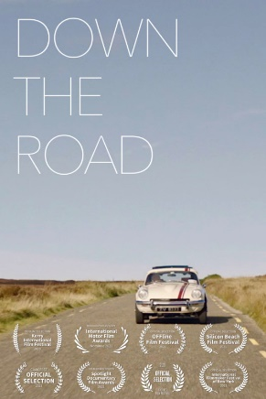
TITLE: DOWN THE ROAD
RUN TIME: 13 MIN
SYNOPSIS:
A short documentary about classic car mechanic Alan Egan, one of the few remaining craftsmen in modern Ireland, focusing on his passion and skill set, revealing what's lost when technology takes over.
COUNTRY OF ORIGIN: IRELAND

TITLE: EKAI
RUN TIME: 20 MIN
SYNOPSIS:
A short documentary depicting the story of young transgender boy Ekai Lersundi, who took his own life in 2018 after struggling with the bureaucracy surrounding hormone replacement therapy assignment
COUNTRY OF ORIGIN: SPAIN
TITLE: FRINGES OF BURLESQUE, THE
RUN TIME: 12 MIN
STATUS: WORLD PREMIERE
SYNOPSIS:
The Fringes of Burlesque is a short documentary film about the other side of burlesque. Fringe is defined as a person who doesn't fit in. Director Jack Truman and burlesque legend Opal Dockery travel the country and interview burlesque dancers young and old to show the unconventional side of burlesque. A shocking, eye-opening documentary, The Fringes of Burlesque opens the audience's eyes to a life less travelled.
COUNTRY OF ORIGIN: UNITED STATES

TITLE: GREEN PATROL IN ACTION: BREZJAK – SMELLS LIKE A FRAUD!
RUN TIME: 29 MIN
SYNOPSIS:
The world-famous company Rio Tinto wants to exploit jadarite ore in western Serbia. Western Serbia is an agricultural and tourist region, where citizens are engaged in beekeeping, fruit growing, animal husbandry, farming and do not want to move out due to the arrival of this company. In addition, Rio Tinto is known for its irresponsible and risky behavior when it comes to work ethic and environmental protection. Behind this company in the world remain devastated spaces and civil wars.
COUNTRY OF ORIGIN: SERBIA
SPECIAL NOTES:
Website: http://www.vojvodjanskazelenainicijativa.org.rs/
Facebook: https://www.facebook.com/zelenapatrolanadelu/
Twitter: https://twitter.com/vzi_zp
Instagram: https://www.instagram.com/ruzahelac/

TITLE: GREEN PATROL IN ACTION: FRUSKA GORA NATIONAL PARK – THERE GOES OUR FOREST
RUN TIME: 26 MIN
SYNOPSIS:
In the Fruška Gora National Park, a few years back the forest is being cut. Tree felling is done by the National Park management to provide salaries for employees, that is the official explanation. However, it is assumed that it is an organized crime given the extent of logging.
COUNTRY OF ORIGIN: SERBIA
SPECIAL NOTES:
Website: http://www.vojvodjanskazelenainicijativa.org.rs/
Facebook: https://www.facebook.com/zelenapatrolanadelu/
Twitter: https://twitter.com/vzi_zp
Instagram: https://www.instagram.com/ruzahelac/

TITLE: GREEN PATROL IN ACTION – FUTOG – A VERY HUNGRY MAN
RUN TIME: 28 MIN
SYNOPSIS:
On the bank of the international river Danube, the company for the exploitation of gravel and sand devastates the riverbank and endangers the safety of the inhabitants of Futog. The owners of this company are violating many laws, the inspection banned them from working, but they continued to work. While the Green Patrol team was filming the illegal work of the company, the owner of the company attacked journalists and environmental activists.
COUNTRY OF ORIGIN: SERBIA
SPECIAL NOTES:
Website: http://www.vojvodjanskazelenainicijativa.org.rs/
Facebook: https://www.facebook.com/zelenapatrolanadelu/
Twitter: https://twitter.com/vzi_zp
Instagram: https://www.instagram.com/ruzahelac/

TITLE: GREEN PATROL IN ACTION: THE VINEYARDS OF KARLOVCI – WE DON’T TRUST ANYONE
RUN TIME: 29 MIN
SYNOPSIS:
Karlovac vineyards, on the edge of the National Park Fruška gora, are a famous weekend resort. In the hinterland of this settlement there are vineyards and famous wine houses. Wines from Fruška gora were served at royal courts throughout Europe. And now ... There is an industrial zone at this location: a brickyard that uses coke petrol as fuel, an ammonium nitrate storage facility, oil terminals between which the Belgrade-Novi Sad high-speed railway will pass.
COUNTRY OF ORIGIN: SERBIA
SPECIAL NOTES:
Facebook: https://www.facebook.com/zelenapatrolanadelu/
Twitter: https://twitter.com/vzi_zp
Instagram: https://www.instagram.com/ruzahelac/

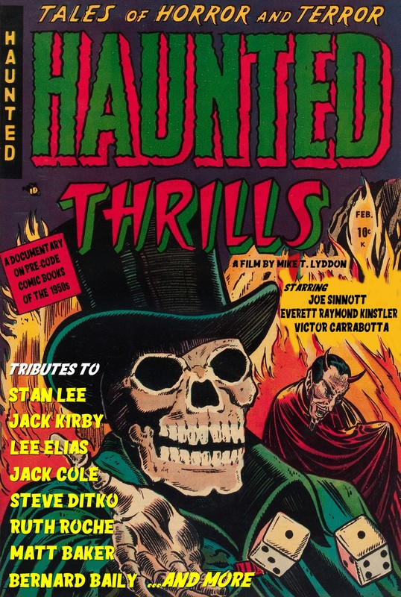
TITLE: HAUNTED THRILLS (2021)
RUN TIME: 25 MIN
SYNOPSIS:
A short documentary film about the lesser known pre-code horror and science fiction comic books of the early 1950s.
Featuring three exclusive interviews with the original pre-code horror comic artists Everett Raymond Kintsler, Joe Sinnott, and Vic Carrabotta, the HAUNTED THRILLS documentary is a love letter to those comics that were ultimately doomed by Dr. Fredric Wertham and the Comics Code Authority in the mid 1950s.
COUNTRY OF ORIGIN: UNITED STATES
SPECIAL NOTES:
Website: http://www.horroranthologymovies.com/
Facebook: https://www.facebook.com/reelprogress/

TITLE: HEARTS ROAD
RUN TIME: 39 MIN
SYNOPSIS:
Hearts Road was photographed in 95 countries and produced over a period of 30 years. It represents one man's journey of evolution, his deep spiritual growth and ultimately his return to the seat of his soul. Transformative and prodigal, it also becomes a journey for every one of us. Take your innermost mind and, through his eyes, and his lens, discover a world that few have ever seen.
COUNTRY OF ORIGIN: UNITED STATES
SPECIAL NOTES:
Website: https://www.heartsroad.film/

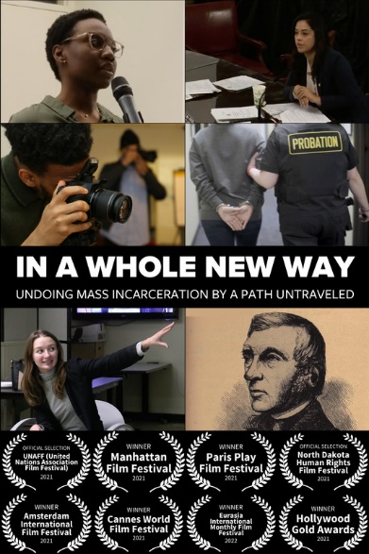
TITLE: IN A WHOLE NEW WAY
RUN TIME: 32 MIN
SYNOPSIS:
Ensnaring almost four million Americans, probation has evolved from a second chance to avoid prison to a sanction feeding mass incarceration. Supported by neighborhood allies, some people of color set out in a whole new way to change all this—equipped only with cameras.
COUNTRY OF ORIGIN: UNITED STATES
SPECIAL NOTES:
Website: https://www.inawholenewway.com/
Facebook: https://www.facebook.com/inawholenewway
Twitter: https://twitter.com/inawholenewway

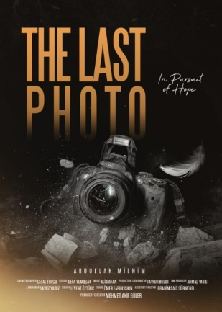
TITLE: LAST PHOTO, THE
RUN TIME: 20 MIN
SYNOPSIS:
Abdullah Milhim is a photographer trying to announce by photographing what is going on in the war zone, Syria to the world. Once, he goes to photograph a just bombed region, he sees an aged man inside the ruins. He is influenced deeply by the situation of the aged man who is just standing and crying while people are escaping and wounded are carried in the chaos, and so he takes the man’s photo. At the very moment, aircraft noise is heard, and a bomb is dropped near them. After that day, Abdullah starts looking for his last photo, a new arm and his future.
COUNTRY OF ORIGIN: TURKEY

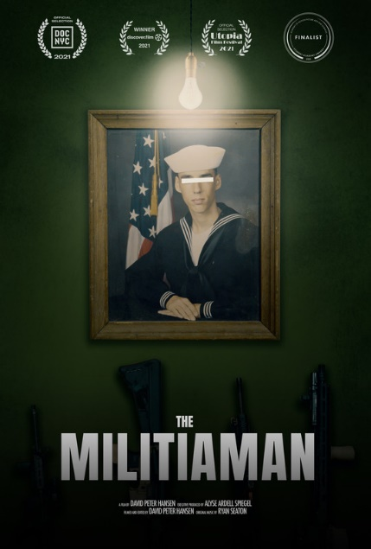
TITLE: MILITIAMAN, THE
RUN TIME: 32 MIN
SYNOPSIS:
In the hills of rural Pennsylvania, the leader of a local militia must prepare his men for the turbulent political landscape of 2020 while at war with his own conscience.
For over ten years, 48-year-old Iraqi War Veteran and machinist Christian Yingling has commanded a troop of private militiamen and women concerned with the government’s infringement on their constitutional rights. The group practices paramilitary drills, stockpiles food and ammo, and attends gun rights rallies in preparation for a doomsday scenario. Now that a worldwide pandemic has hit, followed by a summer of racial injustice protests and a Presidential election like no other, Christian—out of work and nearly out of money—must confront his allegiance and choose to act or not.
COUNTRY OF ORIGIN: UNITED STATES
SPECIAL NOTES:
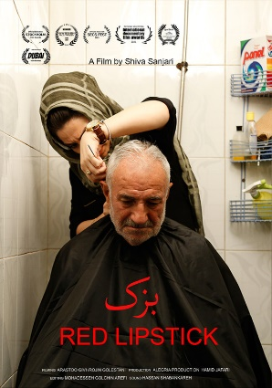
Website: https://themilitiaman.com/
Facebook: https://www.facebook.com/themilitiaman

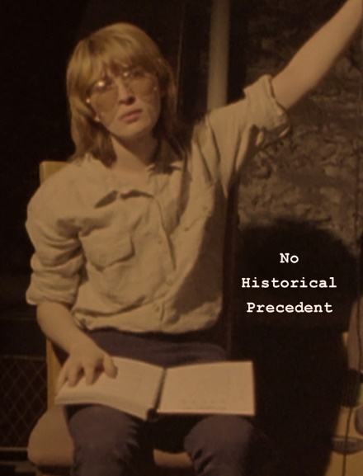
TITLE: NO HISTORICAL PRECEDENT
RUN TIME: 10 MIN
SYNOPSIS:
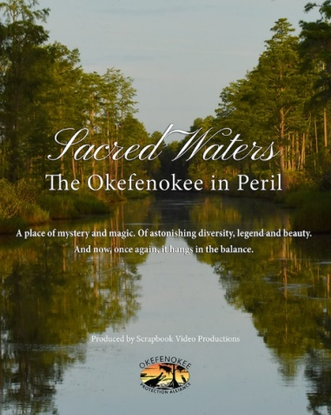
Portrait of a woman who refused to be a transgender icon. Experimental documentary of an undocumented history. Cosplay and cover songs by the #1 fan of Wendy Carlos.
COUNTRY OF ORIGIN: UNITED STATES

TITLE: RABBITTOWN
RUN TIME: 47 MIN
SYNOPSIS:
An informative, entertaining, and emotional story about the economic downfall of a once-thriving community in small-town Alabama and how Its residents are making the most of it.
COUNTRY OF ORIGIN: UNITED STATES

TITLE: RED LIPSTICK
RUN TIME: 42 MIN
SYNOPSIS:
Red lipstick is about a hairdresser called Masoumeh who is 36 years old and she never got married!
Her beauty salon is in a poor neighborhood of Tehran Called Shoosh.
COUNTRY OF ORIGIN: ISLAMIC REPUBLIC OF IRAN

TITLE: SACRED WATERS: THE OKEFENOKEE IN PERIL
RUN TIME: 33 MIN
SYNOPSIS:
Sacred Waters: The Okefenokee in Peril takes viewers into the heart of the Okefenokee National Wildlife Refuge, showcasing its mystical natural beauty, cultural importance, and incredible ecological value. But, as the title of the film sets forth, the sacred waters of the Okefenokee are in peril. The threat of a proposed mineral mine near the edge of the Okefenokee looms large, putting the natural integrity of the Swamp at risk. As Sacred Waters brings us deeper into the Okefenokee, we understand how great this threat truly is.
COUNTRY OF ORIGIN: UNITED STATES
SPECIAL NOTES:
Website: https://protectokefenokee.org/documentary/
Facebook: https://www.facebook.com/protectokefenokee
Instagram: https://www.instagram.com/okefenokeeprotectionalliance/

TITLE: SELECTED MILK (ADDED FROM RECONSTITUTED MILK POWDER WHOLE PASTEURIZED HOMOGENIZED) - RAW
RUN TIME: 20 MIN
SYNOPSIS:
“Selected Milk (Added from Reconstituted Milk Powder Whole Pasteurized Homogenized)”, is in the form of a manual for sellers of milk cartons in supermarkets. Meanwhile, the scenes reflect the flashes of life of a potential seller who does not meet the conditions of a milk carton salesman.
COUNTRY OF ORIGIN: SPAIN

TITLE: TODDLER TALKS
RUN TIME: 3 MIN
SYNOPSIS:
Toddler Talks is a series of short animations based on audio recordings of my toddler-aged son, Henry. The film is animated in a way that mimics our development of language and emotions -- which aren't clear and articulated at first.
COUNTRY OF ORIGIN: UNITED STATES
SPECIAL NOTES:
Website: https://dianareichenbach.com/toddler-talks

TITLE: WHO KILLED JAZZ?
RUN TIME: 23 MIN
SYNOPSIS:
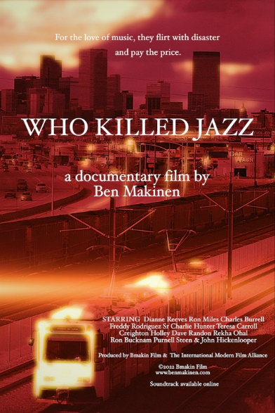
Elite professional jazz musicians address the elephant in the room: why are musicians living in poverty while the club owners and music distributors profit off their life's work? Have the musicians lost touch with their audience, or have they been duped and enslaved by a brutal music business?
Action packed with live performances and candid behind the scenes confessions!
COUNTRY OF ORIGIN: UNITED STATES

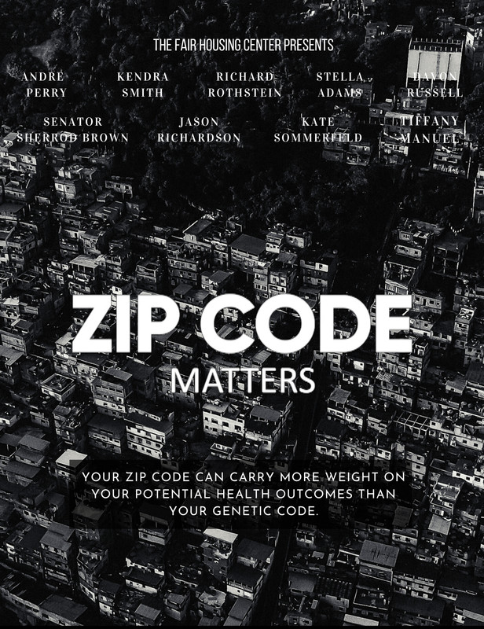

TITLE: ZIP CODE MATTERS
RUN TIME: 29 MIN
SYNOPSIS:
A person’s ZIP Code has been shown to have a greater impact on health and well-being than their genetic code, affecting access to education, transportation, and wealth. How is this possible? This provocative new documentary ZIP CODE MATTERS boldly asks the question and gets profound and insightful answers from the nation’s leading policymakers, nonprofit executives, public health officials and social scientists, researchers, authors, civil rights, and social justice activists. Audiences will learn about the connection between ZIP Codes and the forecast for life outcomes.
Where you live should not determine how long you live, but it does. In fact, health has more to do with place than doctors’ visits. The odds are stacked against low-income communities and communities of color. Because of a legacy of racial and economic segregation, anti-immigrant policy, and a host of other historical “isms,” there are many communities in the United States where the neighborhood environment conspires to harm residents. These environments lack basic health-protective amenities like parks, grocery stores, decent schools, functioning transportation systems, affordable and decent housing, living wage jobs, and even potable water in some instances. Public systems are on life support, stranding residents in pressure cookers of stress. These neighborhood and community environments are not natural; they are manmade and can be unmade.
COUNTRY OF ORIGIN: UNITED STATES
SPECIAL NOTES:
Website: https://zipcodemattersdoc.com/

*******

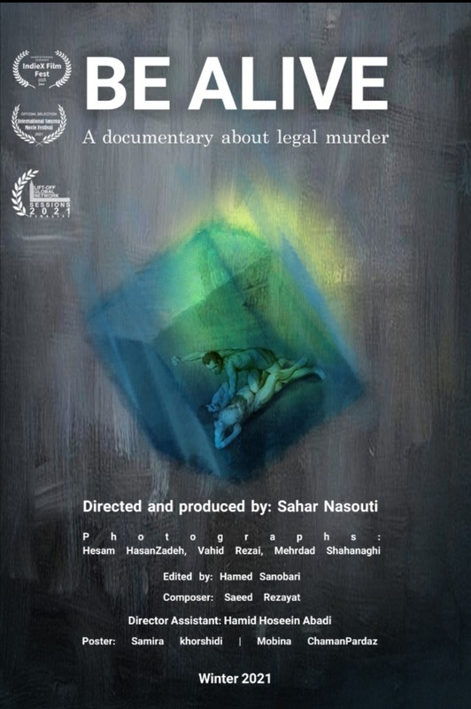
FEATURES:
TITLE: AMERICAN 965
RUN TIME: 96 MIN
SYNOPSIS:
An investigative documentary that raises new questions about the tragic accident of American Airlines flight 965 on 20 December 1995 and reveals facts the aviation industry knew but never disclosed.
COUNTRY OF ORIGIN: UNITED KINGDOM
SPECIAL NOTES:
Website: https://www.american965.com/
Facebook: https://www.facebook.com/American965doc
Instagram: https://www.instagram.com/American965.doc/

TITLE: BE ALIVE
RUN TIME: 63 MIN
SYNOPSIS:
According to Islamic Penal Code, if a person commits murder for any reason, intentionally or unintentionally, the victim's family is considered as “Blood Avengers” and has the right to legal revenge on the killer through the death penalty, an act named “Retaliation”, and also with their consent the victim is released from death.
In this documentary, I have interviewed with many people who have been involved in this issue in some way: from the murderers sentenced to death, to the blood avengers, lawyers and people trying to get the consent of the blood avengers, the family of a person who has been executed and a person who has been executed after interview. I also interviewed someone who witnessed an execution during his military service. I have compared their experiences during this 63 minute documentary.
COUNTRY OF ORIGIN: ISLAMIC REPUBLIC OF IRAN
SPECIAL NOTES:
Website: http://www.saharnasouti.com/
Facebook: https://www.facebook.com/saharnasouti/
Twitter: https://twitter.com/Saharnasouti
Instagram: https://www.instagram.com/Saharnasouti/

TITLE: DARK SHADOWS AND BEYOND: THE JONATHAN FRID STORY
RUN TIME: 102 MIN
SYNOPSIS:
This first documentary devoted to Canadian-born star Jonathan Frid covers the fascinating life and career of the Shakespearean actor, who became a TV icon in the role of vampire Barnabas Collins on the gothic daytime serial, 'Dark Shadows.' Frid’s portrayal was a key reason the series, which ran from 1966 until 1971, became must-see TV for 20 million daily viewers and has been cited as a key influence for contemporary genre films and series such as 'Twilight', 'True Blood' and 'The Vampires Diaries'.
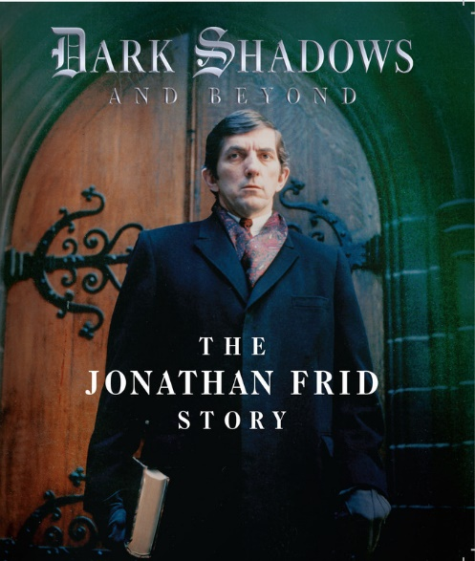
Frid’s characterization of a vulnerable, guilt-ridden monster was forged by his training at RADA in London, Lorne Greene Academy of Radio Arts in Toronto and the Yale School of Drama. This biography of a popular actor evolves into a love letter for the performing arts, exemplified by a man whose devotion to his craft became the driving force in his life.
COUNTRY OF ORIGIN: UNITED STATES
SPECIAL NOTES:
Website:
Facebook: https://www.facebook.com/JonathanFridDoc/
Twitter: https://twitter.com/jonathanfriddoc
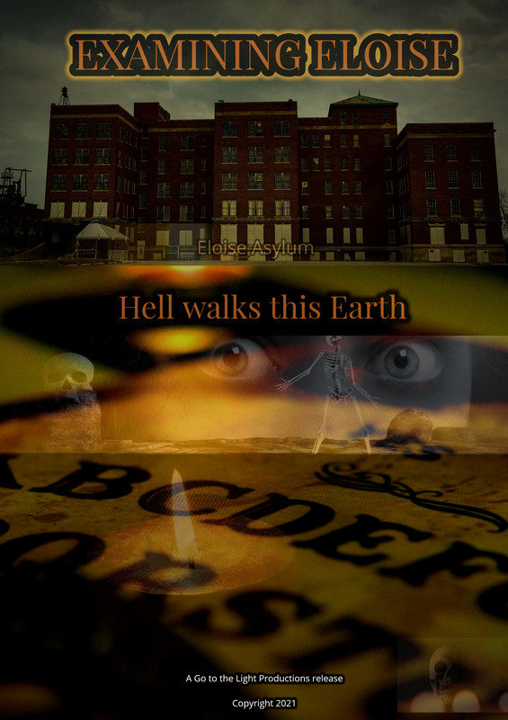
Instagram: https://www.instagram.com/jonathanfriddoc/

TITLE: EXAMINING ELOISE – A CASE STUDY IN MENTAL ILLNESS AND DEMONIC INFLUENCE
RUN TIME: 75 MIN
SYNOPSIS:
Mental illness is a terrible thing, especially if left misdiagnosed.
A team of investigators heads into an abandoned asylum in order to confront dark spirits and make them answer for the pain they have caused.
COUNTRY OF ORIGIN: UNITED STATES

TITLE: FINDING COURAGE
RUN TIME:81 MIN
SYNOPSIS:
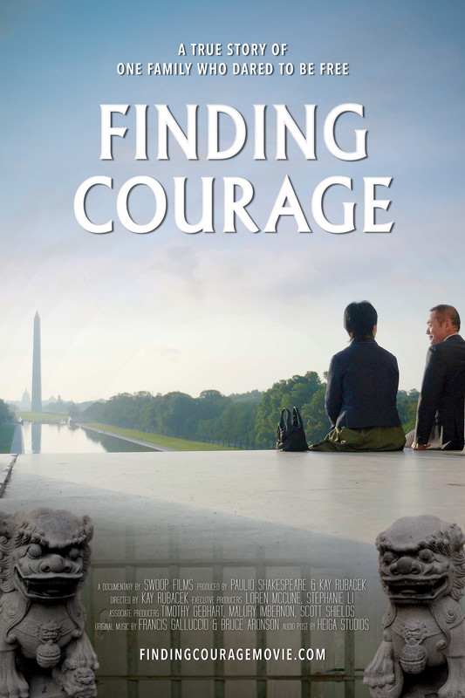
A former journalist for the Chinese Communist Party (YIFEI WANG), living in exile in San Francisco, struggles to settle into life in America while working to heal her family’s wounds from their tragic past. She is seeking justice for the murder of her sister at the hands of the Chinese authorities. Rare undercover footage of a meeting with the director of the labor camp where Yifei’s sister was killed reveals shocking admissions of torture, slave labor, corruption, and a general disregard for human life pervading the camp system today. Exclusive interviews with former Chinese Communist Party officials provide a unique insight into the hidden world of terror that many Chinese citizens live without ever knowing that life can, and does, exist with freedom outside their world.
COUNTRY OF ORIGIN: UNITED STATES
SPECIAL NOTES:
Website: https://www.swoopfilms.com/finding-courage-film/
Facebook: https://www.facebook.com/swoopfilms/?ref=bookmarks
Twitter: https://twitter.com/swoop_films
Instagram: https://www.instagram.com/swoopfilms/
TITLE: FROM THE NEIGHBORHOOD (aka DO BAIRRO)
RUN TIME: 76 MIN
SYNOPSIS:
Within the beating heart of a city, the Hoods meet to tell their story. In a blend of authenticity, roots, traditional music and cause and effect philosophy, they lay it all bare.
COUNTRY OF ORIGIN: PORTUGAL
SPECIAL NOTES:
Website: https://hot-chilli-films.pt/
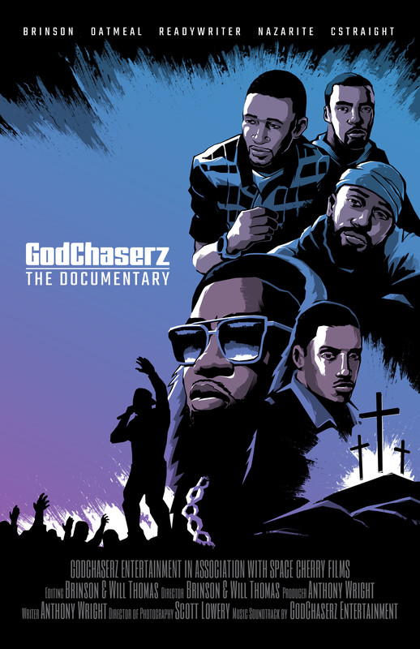
Facebook: https://www.facebook.com/filmedobairro

TITLE: GODCHASERZ: THE DOCUMENTARY
RUN TIME: 68 MIN
SYNOPSIS:
Discover how the artists of GodChaserz Entertainment are using the unlikely pairing of faith and hip hop to disrupt the culture.
Watch the hand of God, change a generation.
COUNTRY OF ORIGIN: UNITED STATES
SPECIAL NOTES:
Website: https://godchaserz.com/
Facebook:
Twitter: https://twitter.com/GodChaserz
Instagram: https://www.instagram.com/GodChaserz/

TITLE: HEARTS ROAD
RUN TIME: 95 MIN
SYNOPSIS:
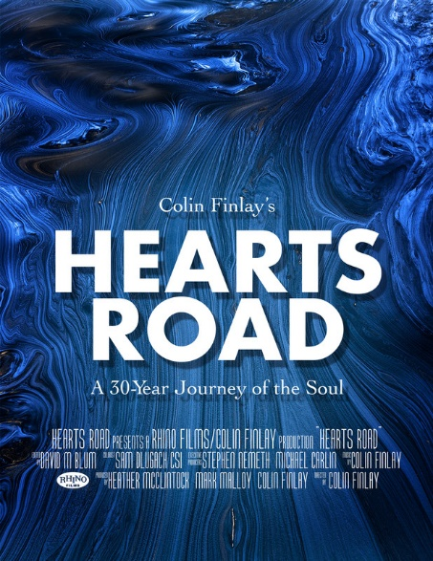
Hearts Road was photographed in 95 countries and produced over a period of 30 years. It represents one man's journey of evolution, his deep spiritual growth and ultimately his return to the seat of his soul. Transformative and prodigal, it also becomes a journey for every one of us. Take your innermost mind and, through his eyes, and his lens, discover a world that few have ever seen.
COUNTRY OF ORIGIN: UNITED STATES
SPECIAL NOTES:
Website: https://www.heartsroad.film/
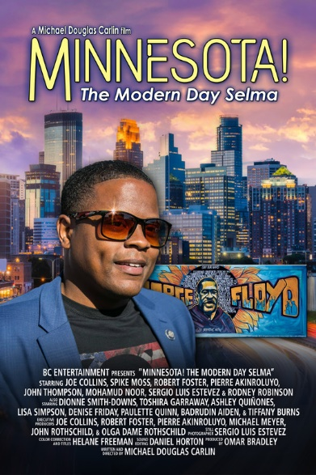
TITLE: MARZO. CHRONICLES OF A LIFE
RUN TIME: 67 MIN
SYNOPSIS:
The story of Marzo, revolutionary and partisan, from the First World War to opposition to fascism; from the Spanish Civil War to the Resistance.
COUNTRY OF ORIGIN: ITALY

TITLE: MINNESOTA: THE MODERN DAY SELMA
RUN TIME: 107 MIN
SYNOPSIS:
The Civil Rights Baton is passed to a new generation.
The murder of George Floyd changed the world. As protests erupted around the world, one group traveled to Minnesota to stand in solidarity with the families of those impacted by police violence. They reached out to politicians and invited them to grieve with the community. For several days nobody came but what these men would accomplish was a surprise even to them.
That last day, candidates and sitting politicians appeared to stand in solidarity with the people. The demands that these men had been making of all the politicians they contacted were being heard and heeded.
But like all movements, there were those standing by to hi-jack their peaceful protest with the stigma of violence. These agitators were stopped from turning the protest violent. Surrounded by police, in a very dangerous situation, there was a narrow path to victory and achievement. These men were able to navigate treacherous waters. But one of them was arrested trying to stop a protester from attacking a police officer.
COUNTRY OF ORIGIN: UNITED STATES
SPECIAL NOTES:
Website: https://minnesota.film/
Facebook: https://www.facebook.com/Michaeldouglascarlin/
Twitter: https://twitter.com/michaeldcarlin
Instagram: https://www.instagram.com/centurycitynews/

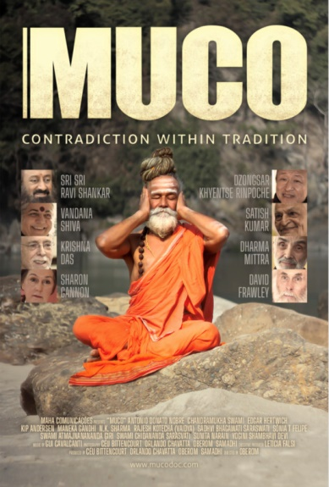
TITLE: MUCO: CONTRADITION WITHIN TRADITION
RUN TIME: 110 MIN
SYNOPSIS:
Two yoga-practicing brothers from Brazil--who live with the environmental impacts of the dairy industry in a place full of natural springs-- travel to India to better understand the spiritual reasons for consuming dairy products. Along the way, they encounter inconvenient truths about the impacts of the dairy industry on the environment, on human health, on animals, and on society.
COUNTRY OF ORIGIN: BRAZIL
SPECIAL NOTES:
Website: https://mucodoc.com/
Facebook: https://www.facebook.com/mucodoc
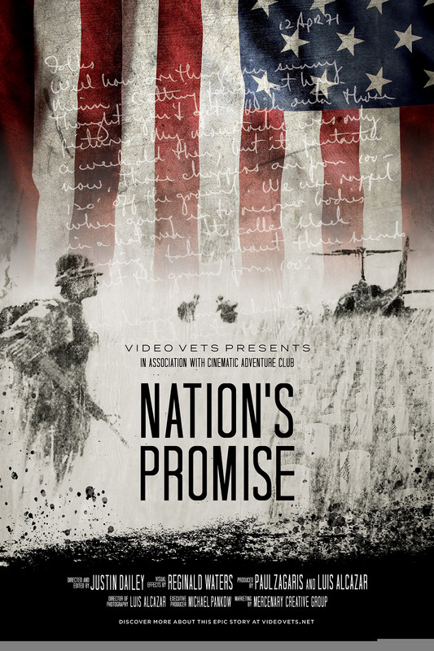
TITLE: NATION’S PROMISE
RUN TIME: 61 MIN
SYNOPSIS:
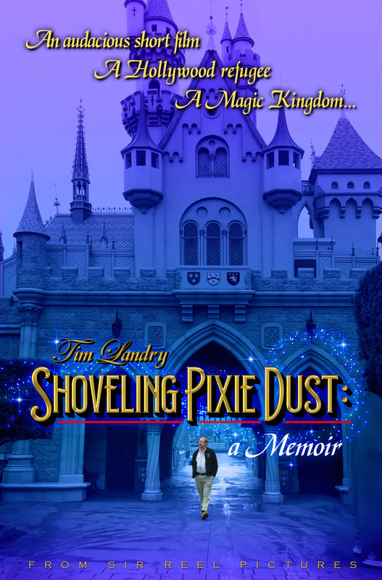
Nation's Promise brings to life the true story of two patriots who, for both love of country and one another, made the ultimate sacrifice during the Vietnam War for our Nation. Inspired by our Nation's commitment to returning all her fallen sons and daughters back to their families and a grateful country, a story is woven that transcends the motivations and politics of war. This is the true story of First Lieutenant Loren Hagen and Sergeant Al Boyers, lifelong friends, divided at time of war, brought together in the quest to find each other. Al Boyers joined an elite group of Special Forces soldiers tasked with carrying out harrowing missions in a clandestine division known as the Studies and Observations Group. After being stranded behind enemy lines, Loren Hagen joins the military to find his best friend, Missing in Action. With never-before-seen footage, Nation's Promise explores one of the most enduring legacies of two men's commitment to one another, a family’s journey to bring them home, and a Nation's Promise to honor all whom have served and made the ultimate sacrifice in defense of the United States of America.
COUNTRY OF ORIGIN: UNITED STATES
SPECIAL NOTES:
Website: https://www.videovets.net/nations-promise
Facebook: https://www.facebook.com/videovets
Twitter: https://twitter.com/videovets
Instagram:

TITLE: SHOVELING PIXIE DUST: A MEMOIR
RUN TIME: 81 MIN
SYNOPSIS:
From producing an audacious short film, to becoming a Hollywood refugee, to building a Magic Kingdom, follow Tim's adventures and struggles as he deals with the challenges of making magic. Enjoy a heartfelt memoir about the making of a Disney Imagineer, covering the entire working career of artist Tim Landry, from film school through to retirement.
COUNTRY OF ORIGIN: UNITED STATES
SPECIAL NOTES:
Website: http://shovelingpixiedust.com/
TITLE: SOCIAL MEDIA MONSTER
RUN TIME: 83 MIN
SYNOPSIS:
When Matthew came to St. Joseph Missouri, no one knew how he would use social media to disrupt the lives of so many people. This documentary looks at how people can get away with doing incredible amounts of damage with little to no consequence. Even when they threaten to commit acts of terrorism at nuclear facilities.
COUNTRY OF ORIGIN: UNITED STATES
SPECIAL NOTES:
Website: https://socialmediamonsterdoc.com/
Facebook: https://www.facebook.com/socialmediamonsterdocumentary
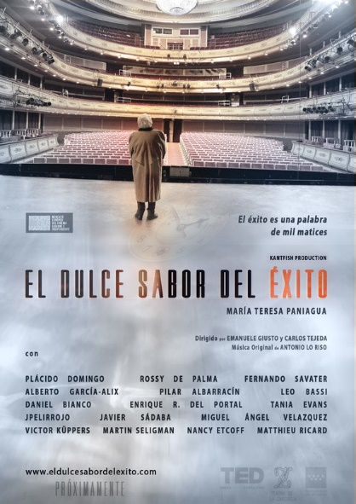
TITLE: SWEET TASTE OF SUCCESS, THE
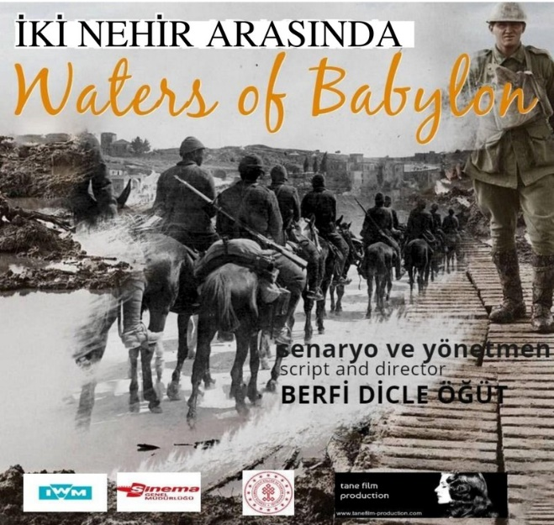
RUN TIME: 75 MIN
SYNOPSIS:
The film is a journey into everyday reality that inspires an intimate, sweet and sour, reflection on the concept of success, with an extraordinary main character and interviews with Rossy de Palma, Plácido Domingo, Fernando Savater, Alberto García-Alix, Matthieu Richard and Martin Seligman of TED Talks, among others.
What is the real meaning of success in life?
This documentary aims to be a balm for the soul.
COUNTRY OF ORIGIN: SPAIN

TITLE: WALTER & THE CHOPPERS
RUN TIME: 83 MIN
SYNOPSIS:
Filled with anecdotes and never-seen-before vintage first-person footage of helicopter operations, this documentary reveals the fascinating and colorful character and life of Walter Gutsche, one of a handful of maverick helicopter pilots ever to have survived war and flown for 50-years without a single incident.
COUNTRY OF ORIGIN: UNITED STATES
SPECIAL NOTES:
Facebook: https://www.facebook.com/walterandthechoppers

TITLE: WATERS OF BABYLON, THE
RUN TIME: 78 MIN
SYNOPSIS:
1914-1918, Burma, Turkish POW camp, and other side Turkey, British POW camp. Hidden truths that remain silent despite the intervening century. Descendants of Turkish and British soldiers who crossed paths in Mesopotamia during the First World War think upon the unknown stories of their grandfathers and how it has affected their lives. The film progresses with testimonies from two different nations' prisoners of war, who have been left outside of the historical framework, and showcases the shared painful effects of war's cruelty upon individuals, and the bond that distinguishes the reality of history from memory and forgiveness.
COUNTRY OF ORIGIN: TURKEY
SPECIAL NOTES:
Website: https://berfidicleogut.wixsite.com/sitem
Facebook: https://www.facebook.com/Waters-of-Baylon-100246358469257/?ref=pages_you_manage

TITLE: WHITE WOLVES: GHOSTS OF THE ARCTIC
RUN TIME: 56 MIN
SYNOPSIS:
At the very northern edge of Canada is Ellesmere Island, where the unforgiving Arctic winds tear through the tundra, dipping temperatures to 40 below zero. Running through this shifting sea of snow and ice is one of the most hardened predators on the planet, the Arctic Wolf. But as the spring melt approaches, these roaming hunters must adapt to being tethered parents as new additions to the pack have just been born.
With never-before-seen footage of wolf family life, Ghosts of the Arctic is a dramatic and touching story of loyalty, companionship and devotion. It’s an epic true tale that reveals the struggles and triumphs of a family working to survive in one of the last great wildernesses on Earth.
COUNTRY OF ORIGIN: GERMANY
SPECIAL NOTES:
Website: http://www.gulofilm.de/en/

TITLE: WHO CARES ABOUT DC?
RUN TIME: 68 MIN
SYNOPSIS:
When I moved from California to Washington, DC in 2007, I didn't realize I was giving my my citizenship. I learned that the 14th and 15th Amendments to the US Constitution didn't apply to DC, because DC isn't a state! Most Americans don't know much about DC, except that it's the nation's capitol. And they don't know that real people live, work and pay very high taxes in the District of Columbia.
"Who Cares About DC?" tells the story of DC's status as America's last plantation through the voices of activists who have been working for decades to make DC the 51st State, realizing the dream of full American citizenship for its more than 700,000 residents.
COUNTRY OF ORIGIN: UNITED STATES
SPECIAL NOTES:
Website: http://whocaresaboutdc.com/
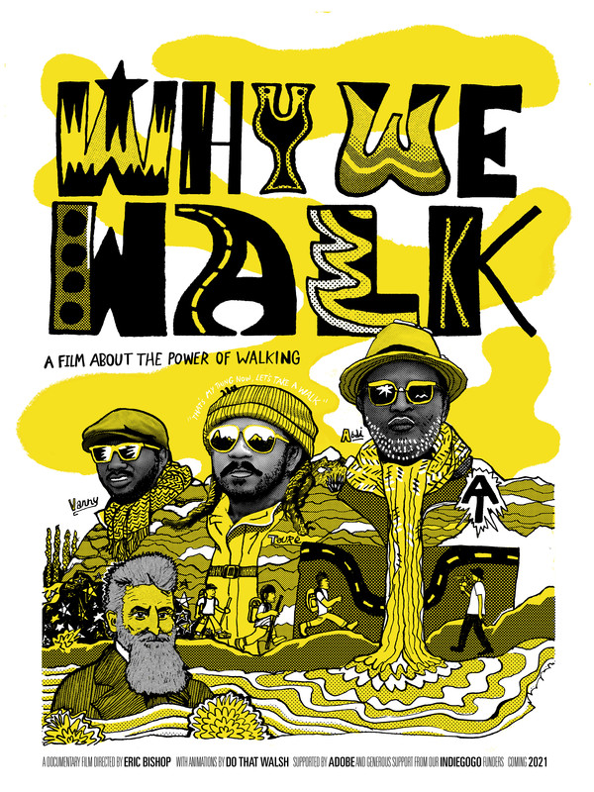
TITLE: WHY WE WALK
RUN TIME: 55 MIN
SYNOPSIS:
WHY WE WALK follows the journey of three Black men, from across the globe, united to empower and de-stigmatize urban communities of color and their participation in the great outdoors. After years of city exploration, The Urban Hikers strive to introduce the power of walking to a community that has historically been underrepresented in this space.
Inspired by the story of the revolutionary abolitionist John Brown, The Urban Hikers embark on a life-changing backpacking pilgrimage from Harpers Ferry, West Virginia- the birthplace of the Civil War- to the nation's capital in Washington, DC.
The Appalachian wilderness serves as a stage to address underlying racial identities and cultural differences within the collective. As tensions rise and provisions dwindle, the team must learn to work as one in order to reach their destination — Mile 0.
COUNTRY OF ORIGIN: UNITED STATES
SPECIAL NOTES:
Website: https://www.whywewalkfilm.com/
Facebook: https://www.facebook.com/whywewalkfilm
Twitter: https://twitter.com/WhyWeWalkFilm
Instagram: https://www.instagram.com/whywewalkfilm/?hl=en

TITLE: WORLD’S BEST FILM, THE
RUN TIME: 89 MIN
SYNOPSIS:
In March 2014, Australian filmmaker Joshua Belinfante was told he might only have a short time left to live. Forced to confront his own mortality, he thought about what he would do with his life if he was somehow given a second chance. He realised that he wanted to travel the world and find people that were fulfilling what their inner child always dreamt of doing. At the time of his diagnosis, Joshua was studying to become a solicitor and had put off his dreams to become a filmmaker. ‘The World’s Best Film’ is an anthology documentary about 13 individuals striving to be the world’s best at their passions.
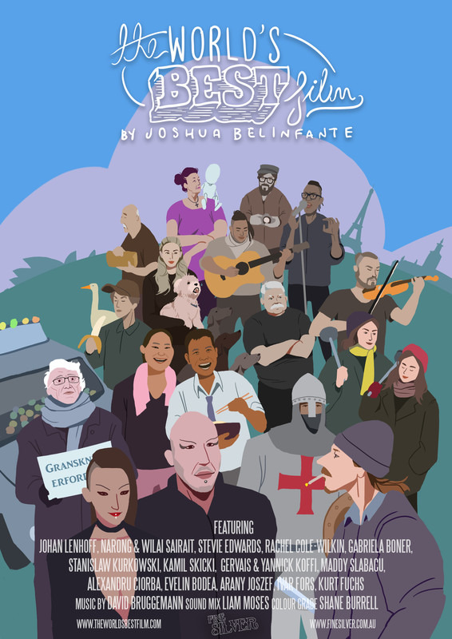
COUNTRY OF ORIGIN: AUSTRALIA
SPECIAL NOTES:
Website: https://www.theworldsbestfilm.com/
Facebook: https://www.facebook.com/theworldsbestfilm
Twitter: https://twitter.com/JDBelinfante
Instagram: https://www.instagram.com/theworldsbestfilm/

We are happy to share this amazing group of short films with audiences as chosen by our staff! These films represent some of the very best qualities of independent film-making and personal stories from the film-makers who wanted to share them with a larger audience.
We hope you enjoy!

“Hall of Fame” Film-Maker 2022
NICK BROOMFIELD
The very first film I ever saw of Broomfield’s was Fetishes (1996) at Georgia State University’s theater (which as a student all screening were free). It was the poster that captured my attention as I had never seen a documentary film on the big screen before and had no interest in them. It was GSU’s small blurb on the film and poster that convinced me to see the film. I was completely taken by Broomfield’s style as he was actually part of the story he was telling. Growing up on nature documentaries and Ken Burns talking heads history documentaries made me completely unprepared for this experience. Needless to say, I became a fan and a junkie for seeing documentary films on the big screen. The real joy of seeing a documentary on the big screen has been the experience that it affords different than watching one on the small screen. It’s an experience that started with Broomfield and has expanded to films from all over the world. I did end up studying non-fiction film in college and producing several of my own shorts and I hope that through the SW DocuFest, I can continue to support and showcase amazing films from film-makers from all over the world.
Kevin L Powers – Co-Festival Director/Program Director

